# Stealth Rockbuster Data Dictionary

Table of Contents:

ERD

Tables

Actor

Address

Category

City

Country

Customer

Film

Film: Actor

Film: Category

Inventory

Language

Payment

Rental

Staff

Store

ERD:

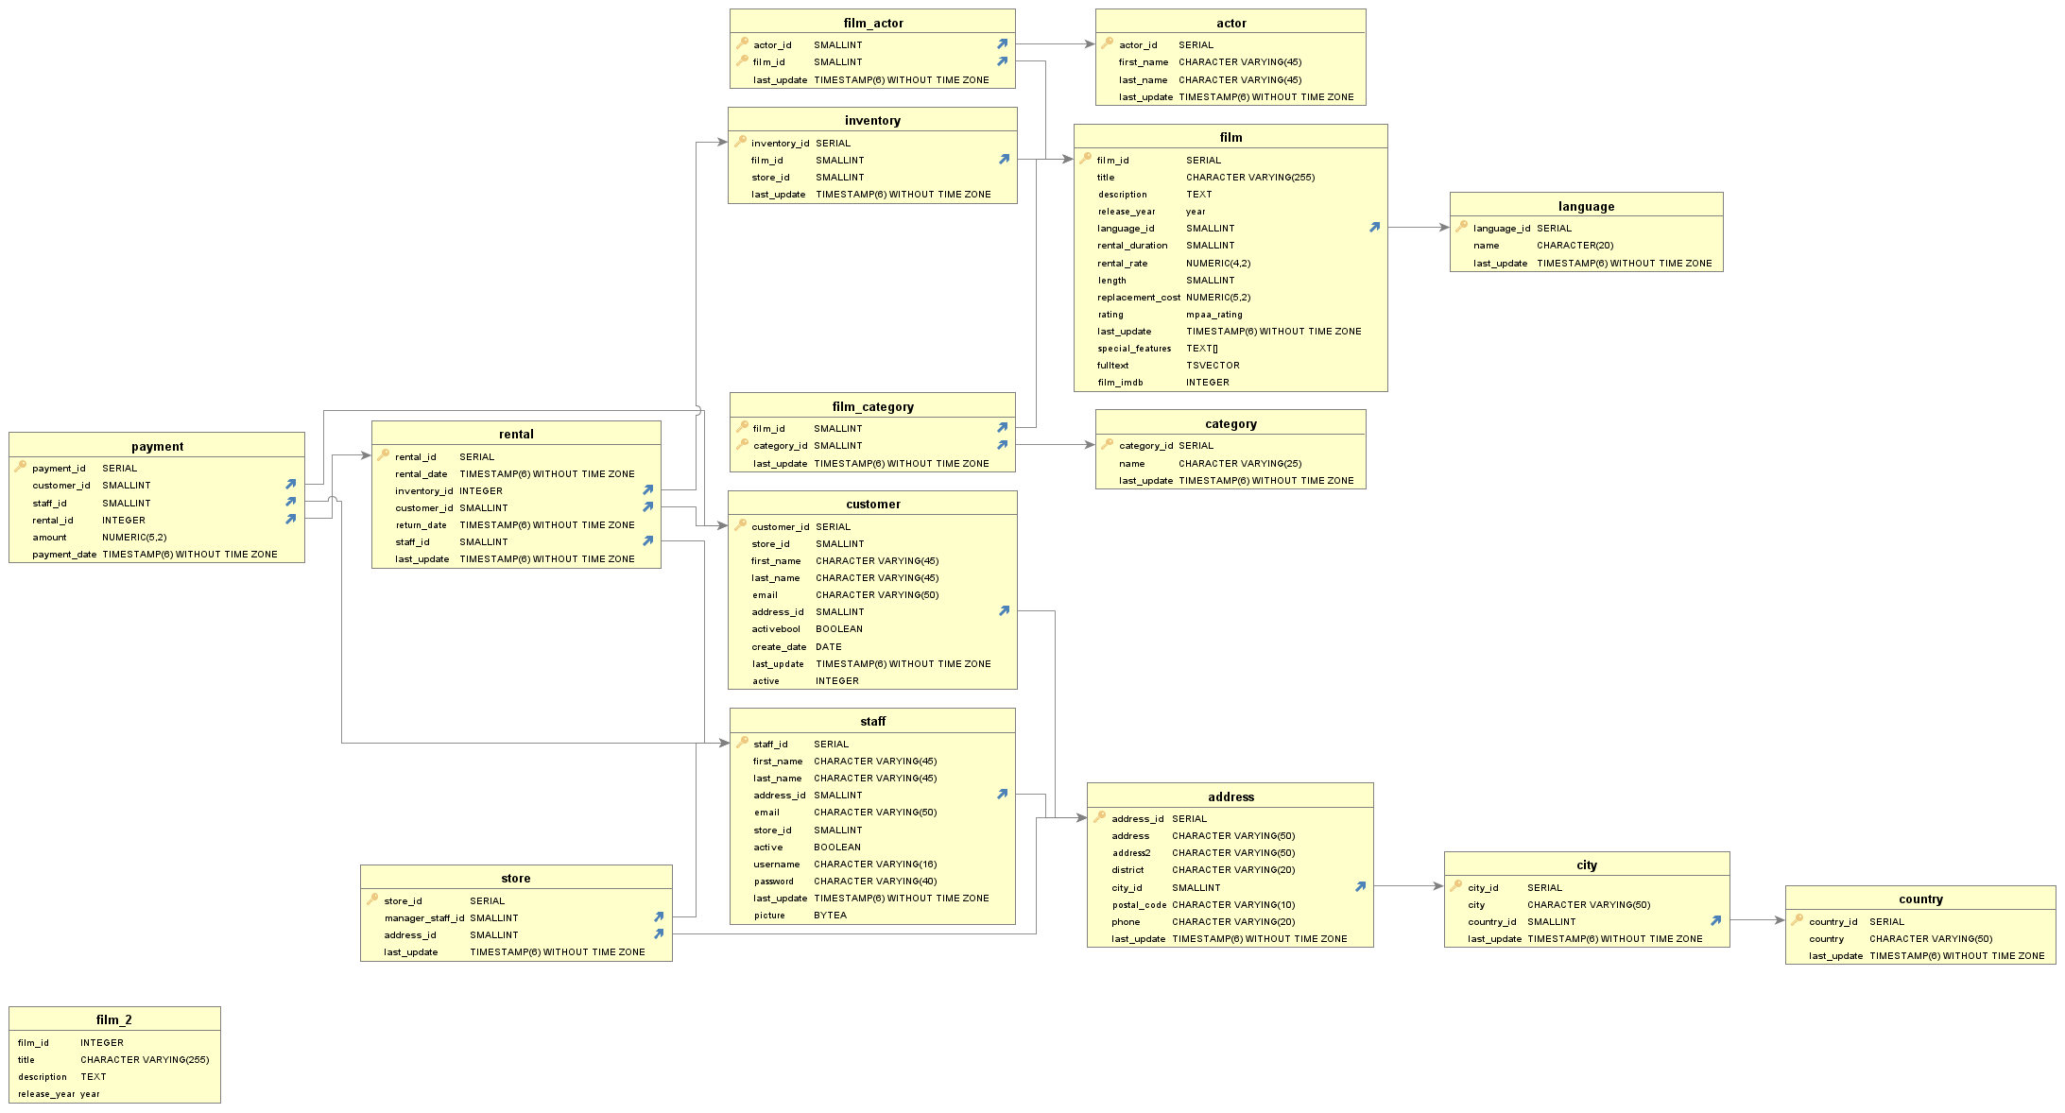

Actor:

|  |  |  |
| --- | --- | --- |
| Name | Data Type | Description |
| Actor_id(PK) | SERIAL | Number ID of each actor |
| first_name | CHAR. VARYING(45) | First name of actor |
| Lat_name | CHAR.VARYING(45) | Last name of actor |
| Last_update | TIMESTAMP(6) WIHTOUT TIME ZONE | Last time the info was updated |
|  |  |  |

Address

|  |  |  |
| --- | --- | --- |
| Name | Data Type | Description |
| Address_id(PK) | SERIAL | ID number for address |
| Address | CHARACTER VARYING(50) | Address of person |
| Address2 | CHARACTER VARYING (50) | Second address of person |
| District | CHARACTER VARYING (20) | State or Province of address |
| City_id (FK) | SMALLINT | ID number for residents city |
| Postal_code | CHARACTER VARYING(10) | Postal Code of person |
| Phone | CHARACTER VARYING(20) | Phone number of person |
| Last Update | TIMESTAMP96) WITHOUT TIME ZONE | Last time info was updated |

Category

|  |  |  |
| --- | --- | --- |
| Name | Data Type | Description |
| Category_id (PK) | SERIAL | ID number for the category |
| Name | CHAR. VARYING(25) | Category name |
| Last_update | TIMESTAMP(6) WITHOUT TIME ZONE | Last time info was updated |

City

|  |  |  |
| --- | --- | --- |
| Name | Data Type | Description |
| City_id(PK) | SERIAL | ID number for city |
| City | CHARACTER VARYING (50) | City’s name |
| Country_id(FK) | SMALLINT | ID number for country city resides in |
| Last_update | TIMESTAMP(6) WITHOUT TIME ZONE | Last time info was updated |

Country

|  |  |  |
| --- | --- | --- |
| Name | Data Type | Description |
| Country_id(PK) | SERIAL | ID number for the country |
| Country | CHARACTER VARYING(50) | Name of country |
| Last_update | TIMESTAMP(6) WITHOUT TIME ZONE | Last time info was updated |

Customer

|  |  |  |
| --- | --- | --- |
| Name | Data Type | Description |
| Customer_id (PK) | SERIAL | ID number for customer |
| Store_id | SMALLINT | ID number for store |
| First_name | CHAR. VARYING(45) | First name of customer |
| Last_name | CHAR. VARYING(45) | Last name of customer |
| Email | CHAR. VARYING(50) | Email address of customer |
| Address_id (FK) | SMALLINT | ID for customers address |
| Activebool | BOOLEAN | True or false variable to indicate if account if active |
| Create_date | DATE | Date account was created |
| Last_updated | TIMESTAMP(6) WITHOUT TIMEZONE | Last time info was updated |
| Active | INTEGER | Integer to see if account active or not |

Film

|  |  |  |
| --- | --- | --- |
| Name | Data Type | Description |
| film_id(PK) | SERIAL | Identification number of the film |
| Title | CHAR. VARYING(255) | Title of the rented movie |
| Description | TEXT | Description of the rented movie |
| Release_year | YEAR | Release year of the movie |
| Language_id (FK) | SMALLINT | Identification number for language of the movie\ |
| Rental_duration | SMALLINT | How long the movie was rented |
| Rental_rate | NUMERIC(4,2) | ???? |
| Length | SMALLINT | How long the movie was rented |
| Replacement_cost | NUMERIC(5,2) | How much does it cost to replace? |
| Rating | Mpaa_rating | Parental guidance rating |
| Last_update | TIMESTAMPS(6) WITHOUT TIME ZONE | The time info was last updated |
| Special_features | TEXT[] | Is there any bonus features with the film (ex. Trailers, Behind the Scenes, etc.) |
| Full_text | TSVECTOR | Full name of the movie |

Film: Actor

|  |  |  |
| --- | --- | --- |
| Name | Data Type | Description |
| Actor_id (PK, FK) | SMALLINT | Actor ID number |
| Film_id (PK, FK) | SMALLINT | Film ID number |
| Last_update | TIMESTAMPS(6) WITHOUT TIME ZONE | Last time info was updated |

Film: Category

|  |  |  |
| --- | --- | --- |
| Name | Data Type | Description |
| Film_id (PK, FK) | SMALLINT | ID number for film |
| Category_id (PK, FK) | SMALLINT | ID number for category |
| Last_update | TIMESTAMP(6) WITHOUT TIMEZONE | Last time info was updated |

Inventory

|  |  |  |
| --- | --- | --- |
| Name | Data Type | Description |
| Inventory_id (PK) | SERIAL | ID number for the stock in inventory |
| Film_id (FK) | SMALLINT | ID number for the film |
| Store_id | SMALLINT | ID number for store |
| Last_update | TIMESTAMP(6) WITHOUT TIMEZONE | Last time info was updated |

Language

|  |  |  |
| --- | --- | --- |
| Name | Data Type | Description |
| Language_id (PK) | SERIAL | ID number for film’s language |
| Name | CHARACTER(20) | Name of language |
| Last_update | TIMESTAMP(6) WITHOUT TIMEZONE | Last time info was updated |

Payment

|  |  |  |
| --- | --- | --- |
| Name | Data Type | Description |
| Payment_id (PK) | SERIAL | ID number for payment |
| Customer_id (FK) | SMALLINT | ID number for customer |
| Staff_id (FK) | SMALLINT | ID number for staff member |
| Rental_id (FK) | INTEGER | ID number for rental |
| Amount | NUMERIC (5,2) | Amount paid by customer |
| Payment_date | TIMESTAMP(6) WITHOUT TIME ZONE | Last time info was updated |

Rental

|  |  |  |
| --- | --- | --- |
| Name | Data Type | Description |
| Rental_id (PK) | SERIAL | ID number for movie rental |
| Rental_date | TIMESTAMP(6) WITHOUT TIME ZONE | Date of rental |
| Inventory_id (FK) | INTEGER | ID for rental in inventory system |
| Customer_id (FK) | SMALLINT | ID number for customer |
| Return_date | TIMESTAMP(6) WITHOUT TIME ZONE | Date the movie rental was returned |
| Staff_id (FK) | SMALLINT | ID number for staff member |
| Last_update | TIMESTAMP(6) WITHOUT TIME ZONE | Last time info was updated |

Staff

|  |  |  |
| --- | --- | --- |
| Name | Data Type | Description |
| Staff_id (PK) | SERIAL | ID number for staff |
| First_name | CHAR. VARYING (45) | First name of staff member |
| Last_name | CHAR. VARYING (45) | Last name of staff member |
| Address_id (FK) | SMALLINT | Id number for staff member’s addresss |
| Email | CHAR. VARYING (50) | Email address of staff member |
| Store_id | SMALLINT | ID number for store |
| Active | BOOLEAN | True or false, indicates if staff account is active |
| Username | CHAR. VARYING (16) | Username for staff member’s account |
| Password | CHAR. VARYING (40) | Password for staff member’s account |
| Last_update | TIMESTAMP(6) WITHOUT TIMEZONE | Last time info was updated |
| Picture | BYTEA | Binary string for stafff |

Store

|  |  |  |
| --- | --- | --- |
| Name | Data Type | Description |
| Store_id (PK) | SERIAL | ID number for store |
| Manager_staff_id | SMALLINT | ID number for store manager |
| Address_id | SMALLINT | ID Number for address |
| Last_update | TIMESTAMP(6) WITH OUT TIME ZONE | Last time info was updated |